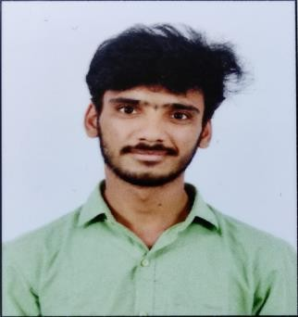CHOKKAPU BALAJI

[**E-mail:**chokkakubalaji999@gmail.com](mailto:chokkakubalaji999@gmail.com)

**Address:** 2-8, ramatemple street, gurlatammiraju peta.

**Phone number:** 7981404888.

# CAREER OBJECTIVE

Seeking a challenging role in a reputed organization where I can learn new skills and expand my knowledge for organization’s growth.

# EDUCATIONAL QUALIFICATION

|  |  |  |  |  |
| --- | --- | --- | --- | --- |
| **Qualification** | **College/ School** | **Board/**  **University** | **Year of**  **passing** | **Percentage**  **/ CGPA** |
| **B.Tech** (Electronics and Communication Engineering) | SRKR Engineering College, Bhimavaram. | Jawaharlal Nehru Technological University, Kakinada | 2023 | 7.4 |
| **Diploma** (Electronics and Communication Engineering)) | Andhra Polytechnic, Kakinada. | State Board of Technical Education and Training | 2020 | 78.5% |
| **SSC** | Z.P.H. School, Mentada. | Board of Secondary Education(AP) | 2017 | 9.3 |

**PROJECTS**

**Title**: Automatic Solar Tracker **Duration**: 1 month

**Domain:** embeded

* **Description**: Automatic solar tracker increases the efficiency of the solar panel by keeping the solar panel aligned with the rotating sun. It tracks the sun position that increases the power output of the solar panel.

**Title**: Home Automation **Duration**: 4 months

**Domain:** IOT

* **Description**: In this project we learn how to make IoT Based Home Automation Project using Blynk & NodeMCU. One of the most common & popular hobby projects you will come across the internet is [Smart Home Automation Project.](https://how2electronics.com/iot-based-smart-kitchen-automation-monitoring-with-esp8266/)

# EXPERIENCE

6 months of training in Networks and Hands-on Experience in Network Academy (CCNA).

# TECHNICAL SKILLS

Programming Languages : Core JAVA, HTML, CSS, Javascript, Reactjs basics.

Designing Softwares : Multisim, Xilinx Vivado

Productivity tools : MS Office, Google Forms, MS PowerPoint

# EXTRA CURRICULAR ACTIVITIES

* Participated as Volunteer for TRANCE event in SRKR Engineering College
* Plays a role of executive body member (EBM) in IETE Organization.
* Got “consolation 3rd prize” for Automatic Solar Tracker project, an event held at SRKR institutions.

# PERSONAL TRAITS HOBBIES

* Adaptability. cooking
* Time management. Playing cricket

# DECLARATION

I hear by declare that the above-furnished information is true, complete and correct to the best of Knowledge.

**Place :** Vizianagaram. **Signature**

**Date : 10**/05/2024 ch.balaji